The following is a conveyor belt system that is used for placing a labels on packages. A logic one (SET) signal will allow relay to energize the motor with a 12 V source. You are also given a few IR Break Beam Sensors (very similar to the ones that are used in grange door openers). If the beam is broken (there is an object between transmitter and receiver), then the logic at the receiver pin (RB2) is zero (0).
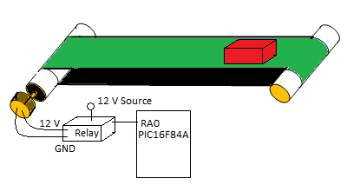
Fig 1-Conveyor Belt System
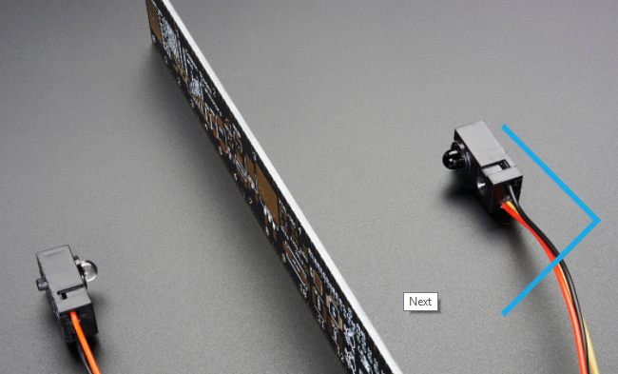
Fig 2. IR Break Beam Sensors
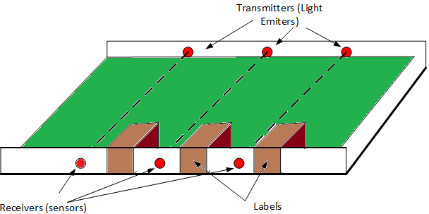
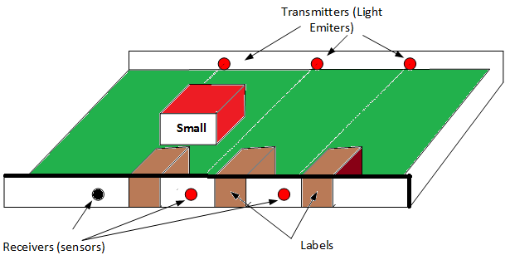
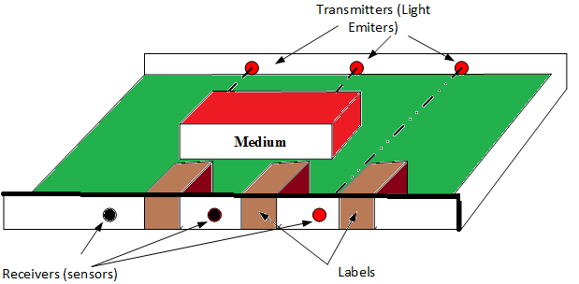
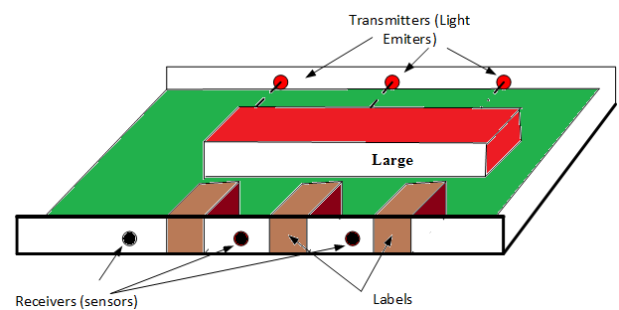

- Design a labeling system based on a PIC16F84A that detects 3 different size of boxes on the conveyor belt and places labels Large, Medium, or Small on the boxes. The system must have an on/off switch as well.
  - Draw the schematic design of the system on a PIC16F84A microcontroller
  - Identify the input and output pins in your design
  - List the names and functions of the subroutines that you plan to develop for this system
  - Draw the flowcharts of the software for your design (for all subroutines and main program)
  - Develop each subroutine
  - Develop your main program

